VIRTUAL SUCCESS SUMMIT 15TH MAY, 2023
TOPIC: BENEFITS OF MAINTAINING A BALANCED LIFESTYLE
SPEAKER: DR. TONY ORJI
INTRODUCTION
- I welcome you all to this Special Virtual Success Summit
- Success Tonics International is a Capacity Building platform for motivating and inspiring young people and young Professional to succeed and excel in all fields of endeavor or areas of calling
- The principles of Success that we teach are firmly rooted and founded on God’s word.
- We have come to realize that it only through God and His word that we can have good Success
  - Josh. 1:8 This book of the law shall not depart out of thy mouth; but thou shalt meditate therein day and night, that thou mayest observe to do according to all that is written therein: for then thou shalt make thy way prosperous, and then thou shalt have good success.
- So true Success lies in God and He is the power to make wealth and succeed in life if we follow His principles.
- Today we are looking at The Benefits of Maintaining a Balanced lifestyle
- Before we proceed, I would like to give you one of the definitions of Success as expounded by Glenn Bland.
- He defined Success as the progressive realization of predetermined worthwhile goal, purified by belief and stabilized by balance!
  - There are three key words you need to note in that definition: These include:
    - Goal---- This defines your focus, target, aim, objective, vision, etc
    - Belief--- This defines your trust, faith, will power and determination to pursue your vision
    - Balance- Thus defines your stability, calmness, composure and steadiness in the pursuit of success.
- These three elements must be present to enjoy long term success
- Other philosophers have also emphasized the need for balance in life:
  - “Fortunate, indeed, is the man who takes exactly the right measure of himself and holds a just balance between what he can acquire and what he can use. - Peter Latham
  - “Happiness is not a matter of intensity but of balance and order and rhythm and harmony”.---- Thomas Merton
  - “Be moderate in order to taste the joys of life in abundance”.----- Epicurus
  - “Balance, peace, and joy are the fruit of a successful life. It starts with recognizing your talents and finding ways to serve others by using them. ---- Thomas Kinkade
  - “The best and safest thing is to keep a balance in your life, acknowledge the great powers around us and in us. If you can do that, and live that way, you are really a wise man”.--- Euripides
  - “Work, love and play are the great balance wheels of man's being.-
    - Orison Swett Marden
  - Wisdom is your perspective on life, your sense of balance, your understanding of how the various parts and principles apply and relate to each other. --- Steven R. Covey
  - The Problem that people have most times is to find a balance between what people need from you and what you need for yourself.----- Jessye Norman

2. WHAT IS BALANCE?
A. a state of equilibrium or equipoise; equal distribution of weight, amount, etc.
B. something used to produce equilibrium; counterpoise.
C. Balance is having the right amount — not too much or too little — of any quality, which leads to harmony or evenness

3. WHAT IS A BALANCED LIFESTYLE?
-The definition of what a balanced life means to each of us may be different, but there are some universal truths.
-For instance: each of us needs a healthy work and life balance to be truly healthy and happy.
-In a survey by the American Psychological Association, work-life balance was found to be one of the top sources of stress for American adults, with 60% citing it as a significant stressor.
- A study by the University of California found that people who experience an imbalance in their work and personal lives are at a higher risk for depression and anxiety, highlighting the importance of balance in maintaining one’s mental health.
-Fundamentally, Man is a tripartite being made up of Spirit, Soul and Body
-The spirit is the real ‘you’, created in the image of God. The soul contains the will, the mind and the emotions. The body is the vessel or container that houses the spirit and the soul.
-So living a balanced life entails keeping the different parts or elements of self in balance and this is fundamental to well-being. These elements are spiritual. emotional, mental and physical!
- Again, to achieve lifestyle balance, you will need to focus on the key components that make up a rich and satisfying life. One useful way of visualising a balanced lifestyle is the “Wheel of Life”, a coaching tool first introduced by Paul Meyer, one of the founders of the practice known today as life coaching.

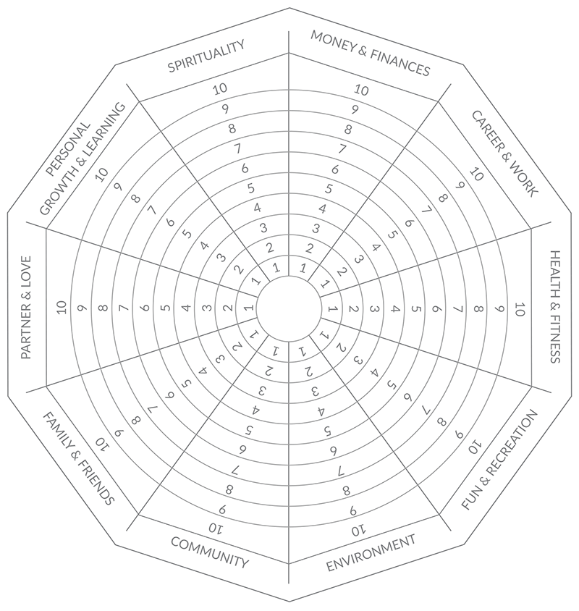
Image source: https://positivepsychology.com/wheel-of-life-coaching/
The Wheel allows people to divide their life into segments, and consider how satisfied they are with each segment. For example:
- Money & Finances
- Skills, Career & Work
- Health & Fitness
- Fun & Recreation
- Environment – Home and Workplace
- Community or Social life
- Family & Friends
- Romantic or love Relationships
- Intellectual life, Personal Growth & Learning
- Spirituality or spiritual life
To create a truly healthy and enjoyable life, we each need to find a balance between all these aspects of our lifestyle that suits our own unique set of circumstances and personal preferences.
-These could further be divided into:

- Internal (Mind, Heart, Health)
- Mind: Challenging yourself intellectually vs. creating opportunities for your mind to rest
- Heart: Giving love vs. receiving love
- Health: Eating, drinking, exercising properly vs. resting. and treating yourself to some extra yummies

External (Work, Social, Family, Fun)
- Work: Pushing yourself to achieve goals vs. seeing the bigger picture and enjoying the ride
- Social: Satisfying your social desires vs. taking time for yourself
- Family: Fulfilling your familial responsibilities vs. creating healthy boundaries
- Fun: Allocating time for things you enjoy doing vs. making sure you don’t overdo it
-Too often, most of us live a life that is far out of balance – putting the things that are not as important first or letting them tip the scales too far in one direction.
4. HOW DO YOU LIVE A BALANCED LIFE?

A. Develop a balanced mindset:

Balance is not just something external; it also lies within you. When something is disturbing you or bothering you, ask yourself why? An out of balance context can definitely affect you, but training your mind can neutralize part of the noise. Balance is a state of mind. You can train your mind to worry less about things and think creatively on how to solve problems, the same way you can train your body to be self-controlled.

B. Prioritize your activities:
To find balance, you must learn to put first things first. Knowing what matters is the first step. Finding balance requires saying no to something else so you can do what you want. Most of the times, we blame others, but we are the ones that are not making a choice. Let go of unnecessary tasks or involvements, ask for help when you need it. Be open to adjusting your goals and priorities

C. Set limits.
The Mayo Clinic warns that “If you don’t set limits, work can leave you with no time for the relationships and activities you enjoy.” Their advice? Learn to say no confidently, and avoid overscheduling your time
D. Integrate different aspects of your life:
You are a complete entity functioning as one. Stop seeing your spiritual activities, work, personal time, and social times as separate compartments. Rather than competing against each other, they should collaborate. Removing this imaginary wall will release a lot of tension. Integrate all aspects by learning and understanding how they all fit into your life, and in what degrees.
E. Lose balance to find balance:
Sometimes you have to lose balance to find it. Letting go of some stringent controls can be the key to let things fall into place on their own. Be open to taking risks. Try something different. Avoid unhealthy routines that are detrimental to your health and well-being. Seek balance in the long-term.
F. Practice Reflections:
Set some time to reflect. Track how you spend your time. Identify the areas of tension and think how to make the necessary adjustments. Also, daily documentation is a great way to capture everything good that happens in life. Acknowledging all the positive things that occurred throughout your day, will make you feel grateful rather than stressing out.
G. Take care and look after yourself – In order to achieve a balanced lifestyle, you must make sure you are healthy. Your body needs plenty of rest, exercise and healthy food. Your body needs healthy foods and nutrients to create new cells, clean toxins and function properly. It’s also important to take some time out from a busy day to enjoy activities and unwind by reading or meditating.
H. Be organised – It’s important to keep a clear mind plan in advance, allowing time for your tasks and making room for activities you enjoy. Being organised can help reduce stress and improve your life balance.
I. Set goals – Achieving goals can help assist with gaining a positive mindset. Your goals can cover anything from your job, your finances or your fitness goals.
J. Take your sleep seriously. -To make sure you get regular, high-quality rest, practice good sleep hygiene. Stick to a consistent bedtime and get up at the same time every day

5. BENEFITS OF MAINTAINING A BALANCED LIFESTYLE
Reduces stress and Improves general health and well being
If you have fewer conflicts inside yourself, you certainly have less stress as well. For example, you do not have to push yourself to go to work on weekends. That makes your life easier and balanced.

Improved work performance
People who can manage work, private life, family, and other social events perform better at work than those who don’t.

Promotes personal growth
As people age, they strive for more personal growth and development. A healthy life balance allows you to achieve higher goals in life.
Improves your mental state of mind – According to helpguide.org eating well and keeping a good life balance can help fight against depression.

Improved relationships- Spending time with people you value maintains healthy and long-lasting relationships. With a balanced life, people can maintain healthy relationships because of less irritability and depression. The rewards of hard work are more fulfilling when you can share them with friends. Good friendships and relationships in return support career progression.
Helps to boost your energy – Eating smart helps provide your body with the nutrients it needs and can lead to improved levels of energy say helpguide.org

Increased focus- A good life balance reduces stress which helps you to work more focused and motivated. Job satisfaction is experienced, amongst others, when family, personal, and job requirements are being respected at the same time.
Improves your mood – It’s not just exercise that can lead to improvement of your mood. Healthy habits such as good social connections can too by keeping the mind active.

Have more time for yourself and for God - Nobody would say you should not do a good job. However, it is a big question mark if your life is all about work and nothing else. A balanced life gives you more time for yourself and for God.

Conclusion:

The main benefit of having a balanced life is that you can live a life with no negative thoughts and no struggle. You do not have to get stuck in a life that you don’t want. Practice balancing your life and enjoy it.

